**Doc: Hina Nadir;**

**Hackathon Day 5 Testing, Error handling And Backend Integration Refinement.**

**Here’s the testing of functions, cart, checkout.**

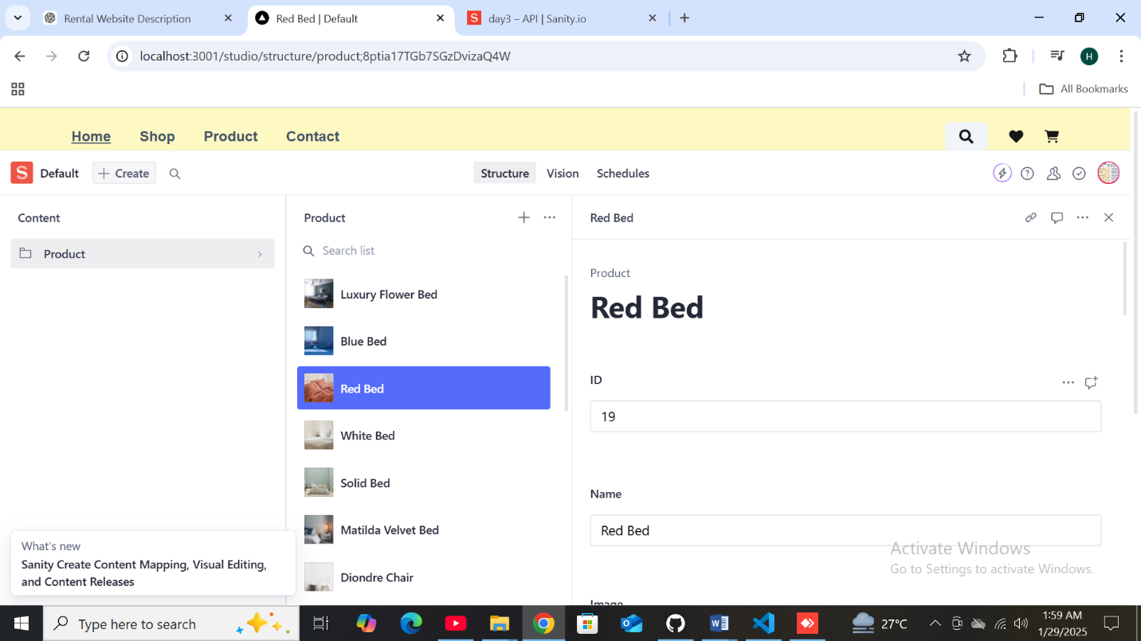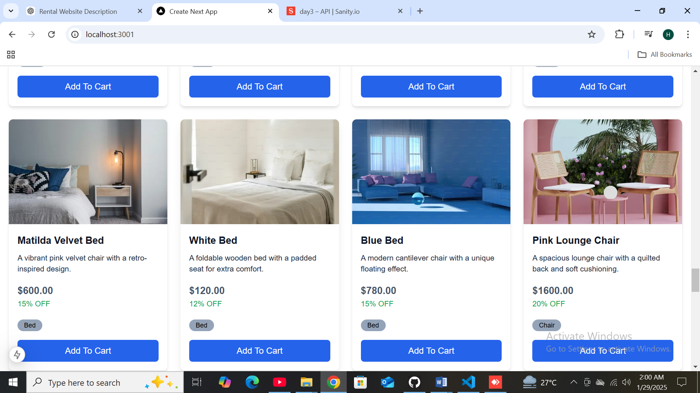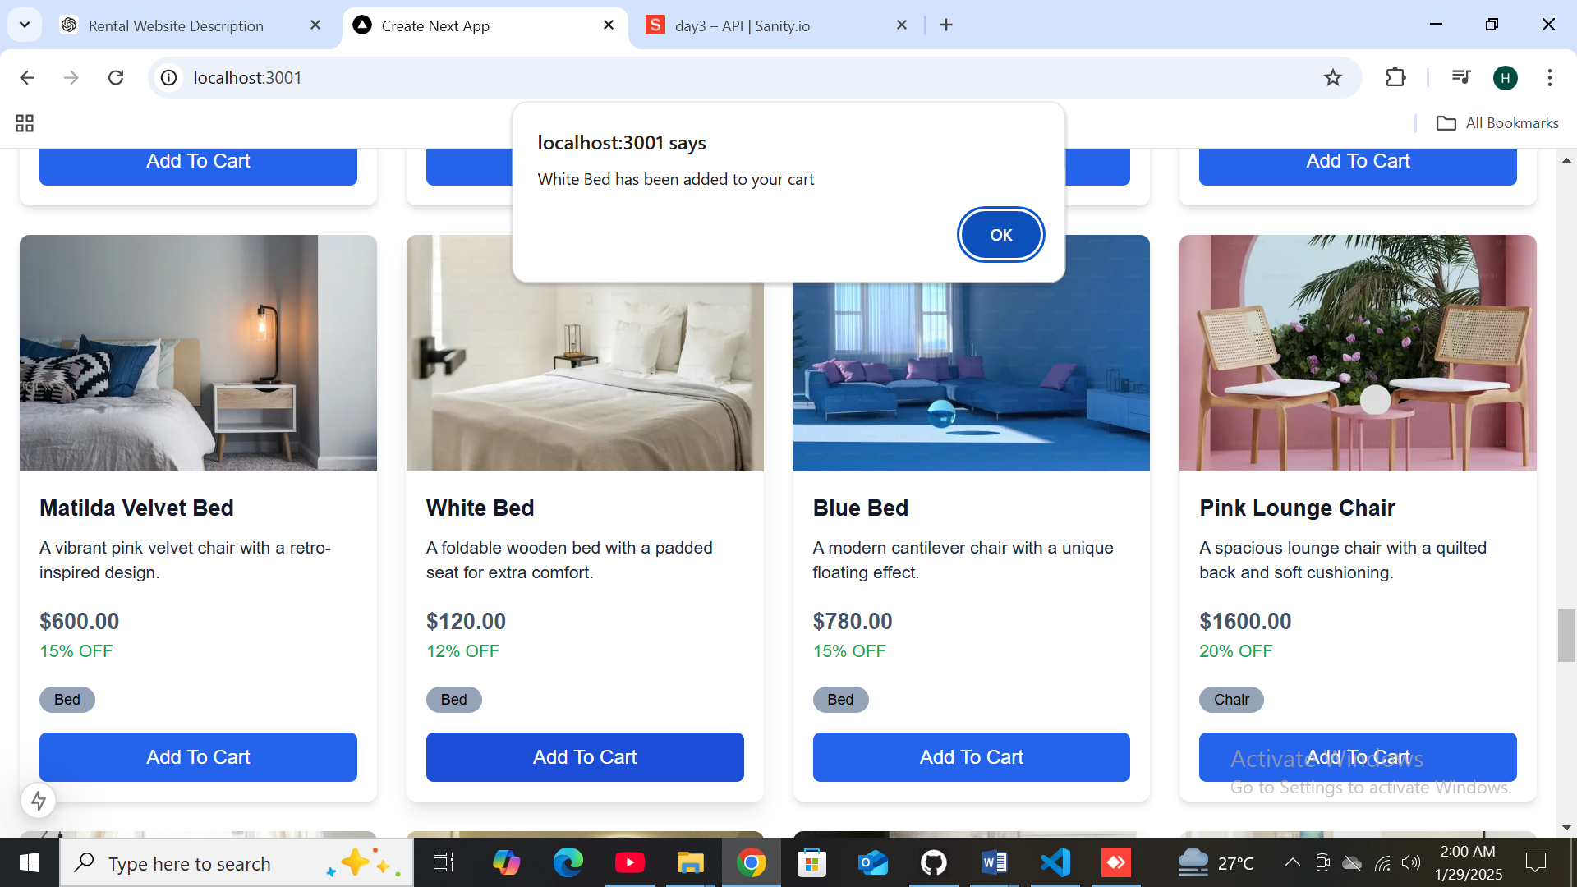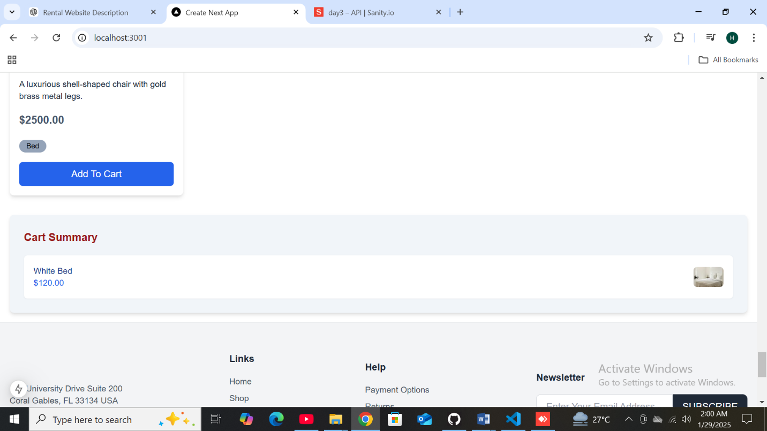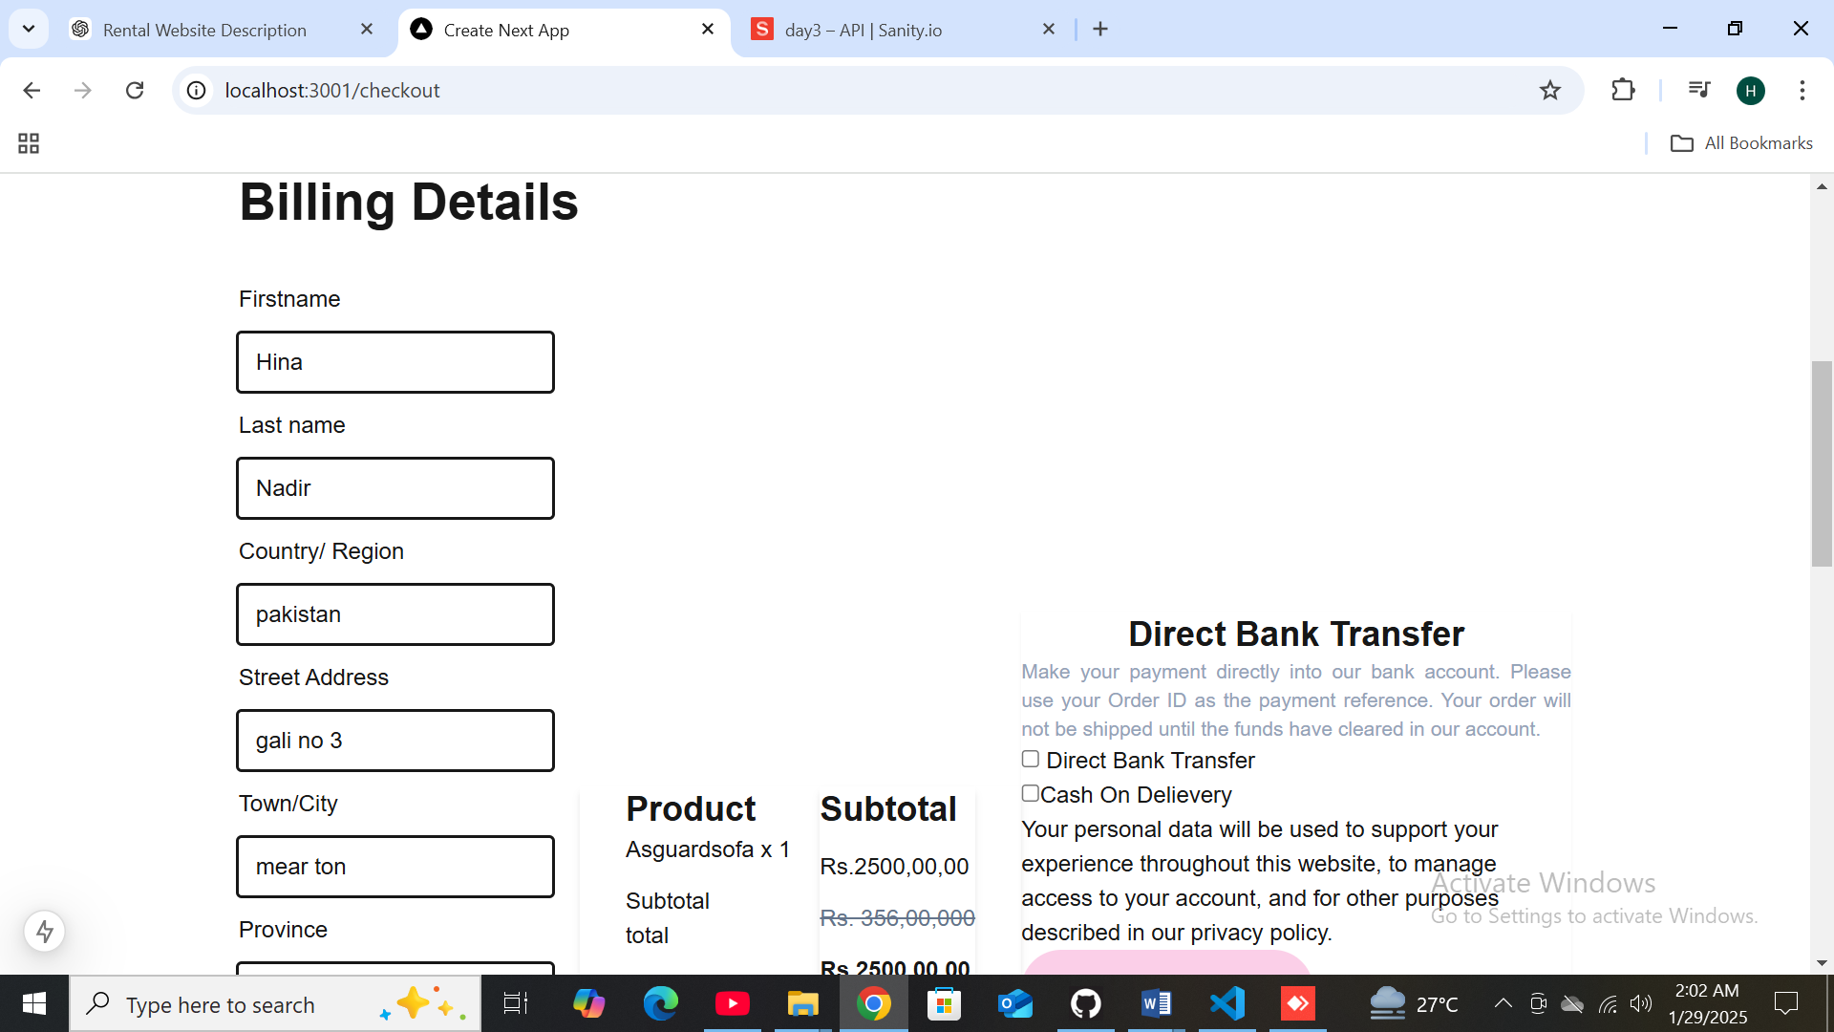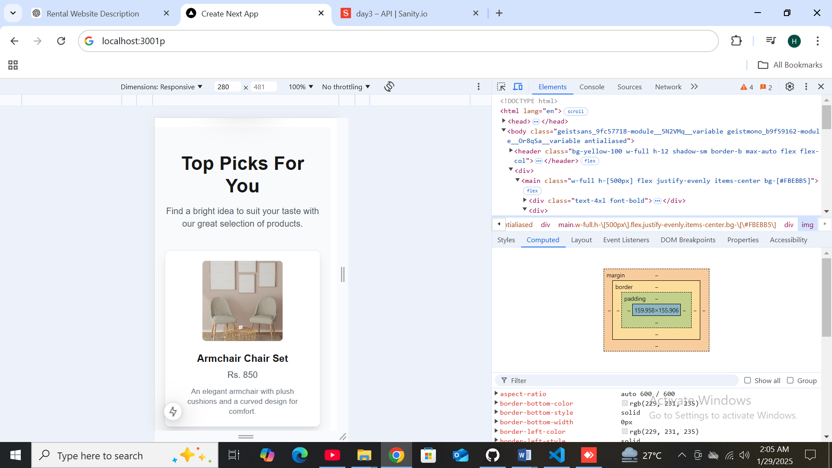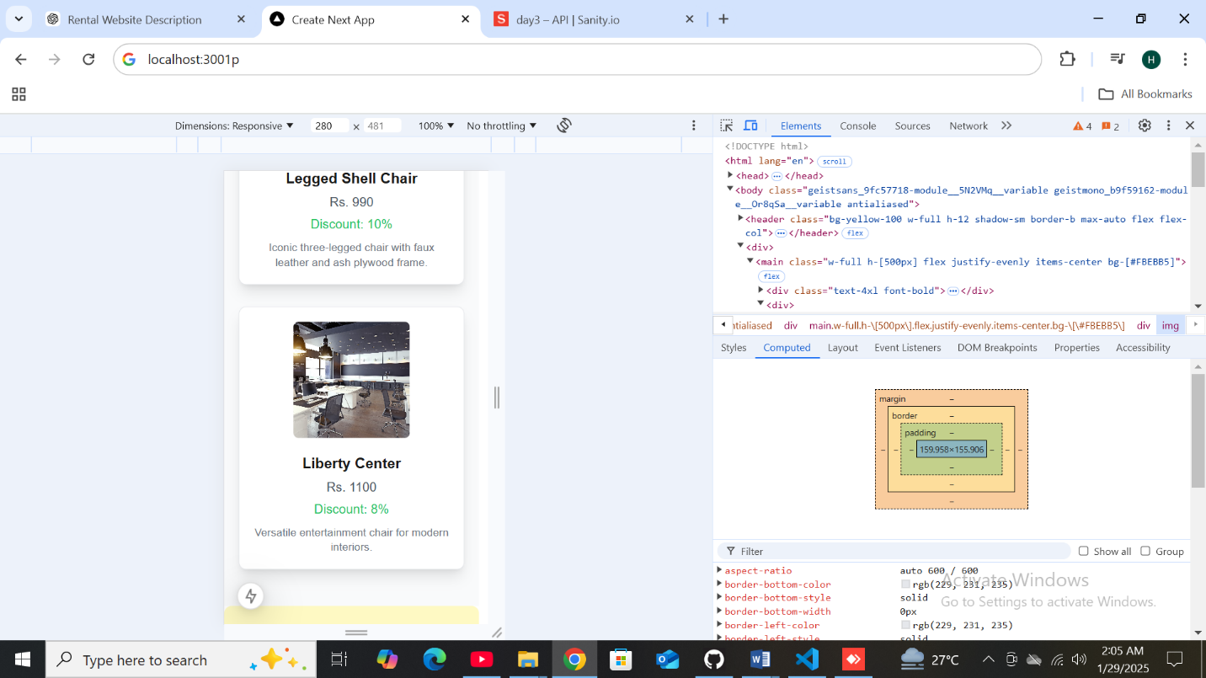

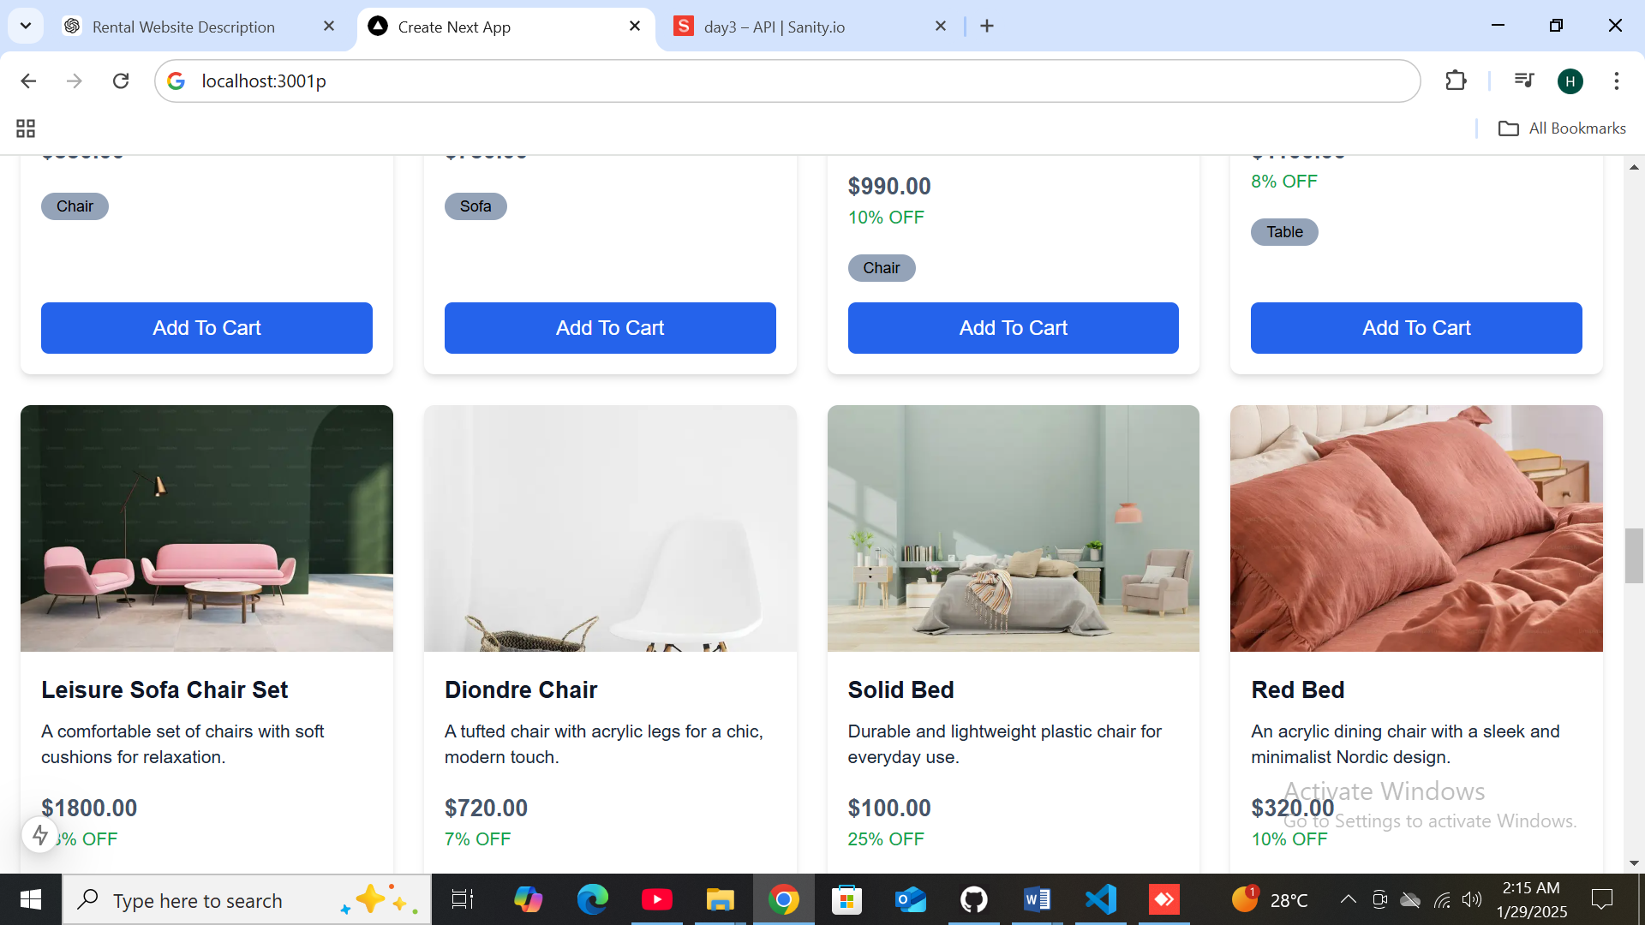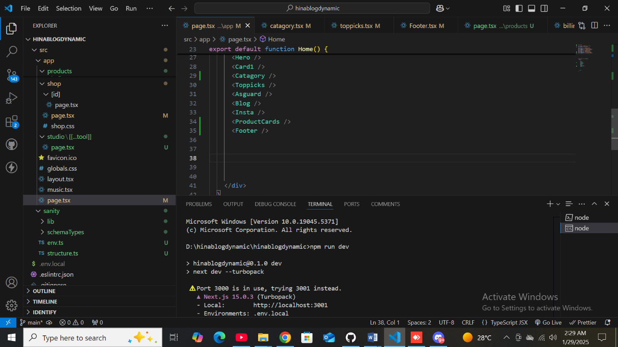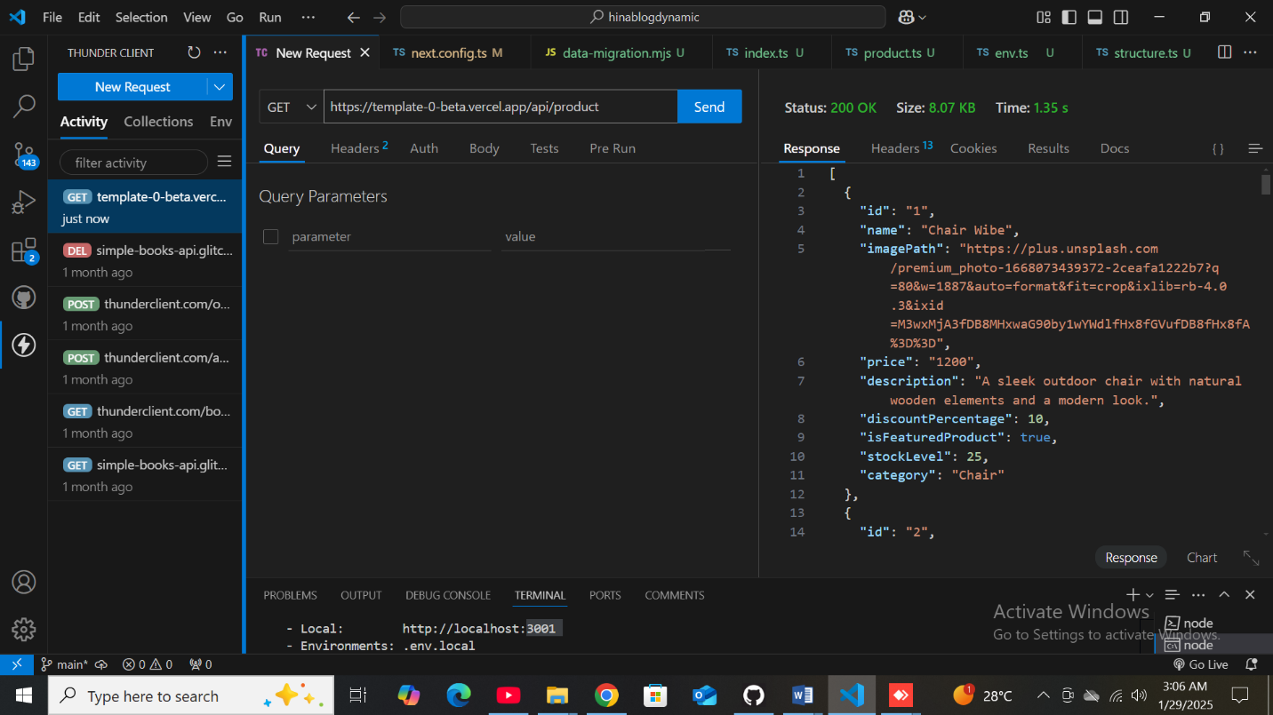

|  |  |  |  |  |  |  |  |  |  |  |  |  |  |  |
| --- | --- | --- | --- | --- | --- | --- | --- | --- | --- | --- | --- | --- | --- | --- |
| **Test Case ID** | **Test Case Description** | **Test Steps** | | **Expected Result** | | **Actual Result** | | **Status** | **Severity Level** | | **Assigned To** | | **Remarks** |  |
| 2 | TC001 | Validate product listing page | | Open product page > Verify products | | Products displayed correctly | | Products displayed correctly | Passed | | High | | - |  | No issues found |
| 3 | TC002 | Test API error handling | | Disconnect API > Refresh page | | Show fallback UI with error message | | Error message shown | Passed | | Medium | | - |  | Handled gracefully |
| 4 | TC003 | Check cart functionality | | Add product to cart > Verify cart contents | | Cart updates with added product | | Cart updates as expected | Passed | | High | | - |  | Works as expected |
| 5 | TC004 | Ensure responsiveness on mobile | | Resize browser window > Check layout | | Layout adjusts properly to screen size | | Responsive layout working as intended | Passed | | Medium | | - |  | Awesome result |
|  |  |  | |  | |  | |  |  | |  | |  |  |  |
|  | | |  | |  | |  | | |  | |  | | | |
|  | | |  | |  | |  | | |  | |  | | | |
|  | | |  | |  | |  | | |  | |  | | | |

**Light –House activity and Checking**

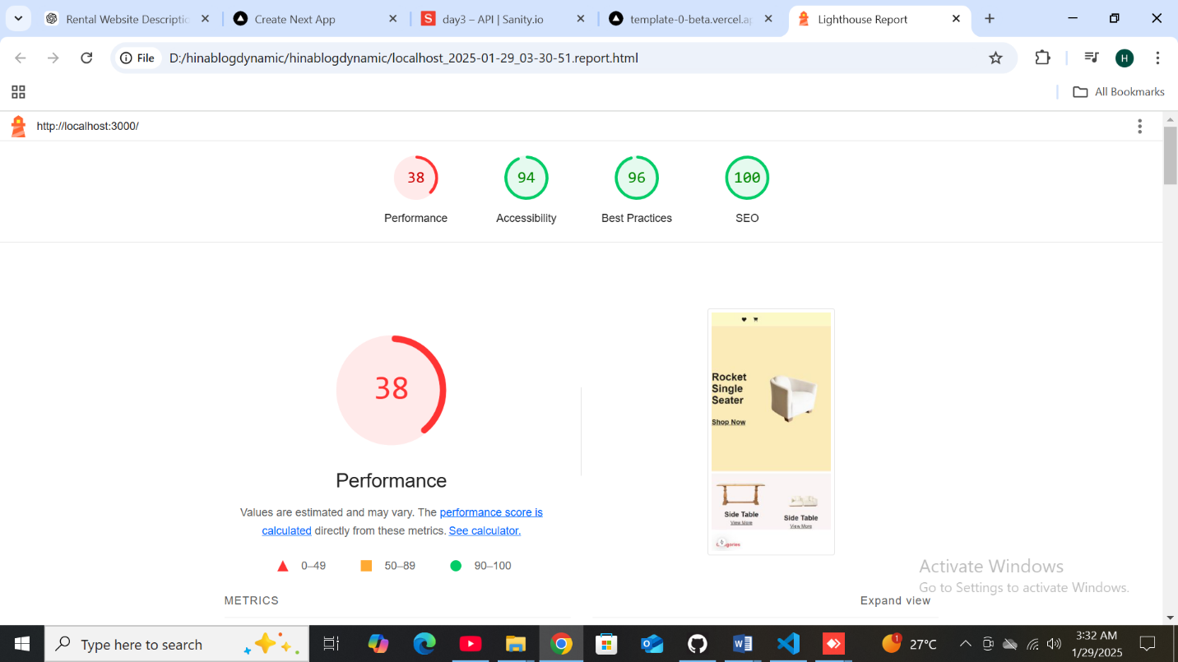



**API Fatching data.**



**LightHouse testing service**



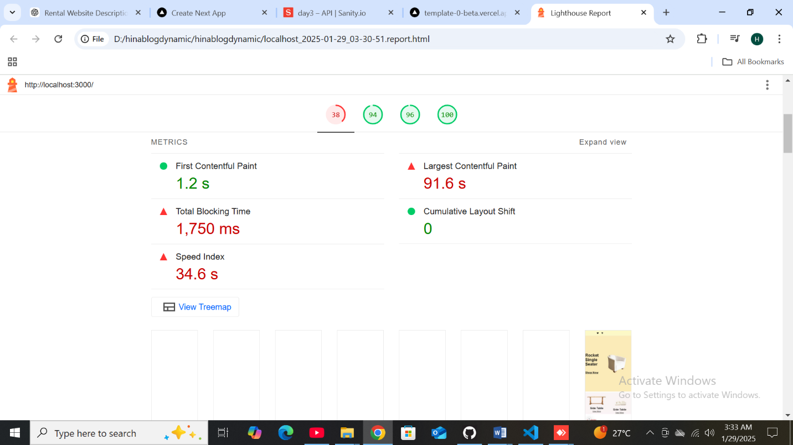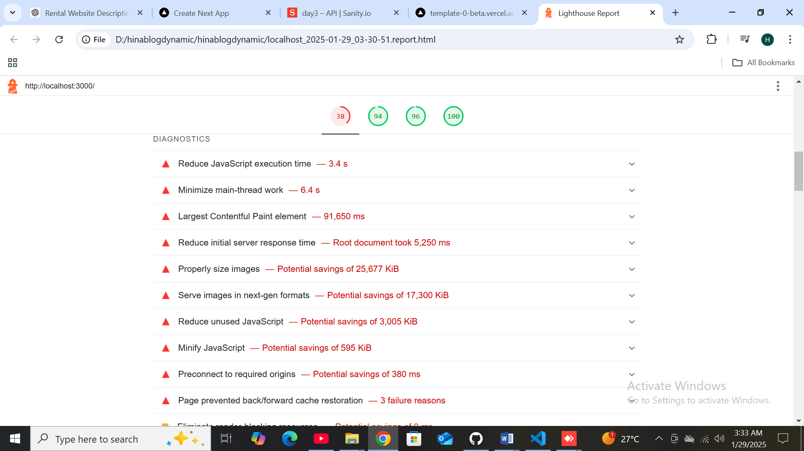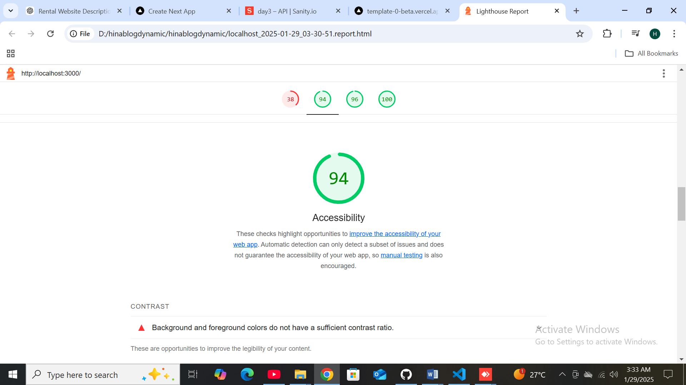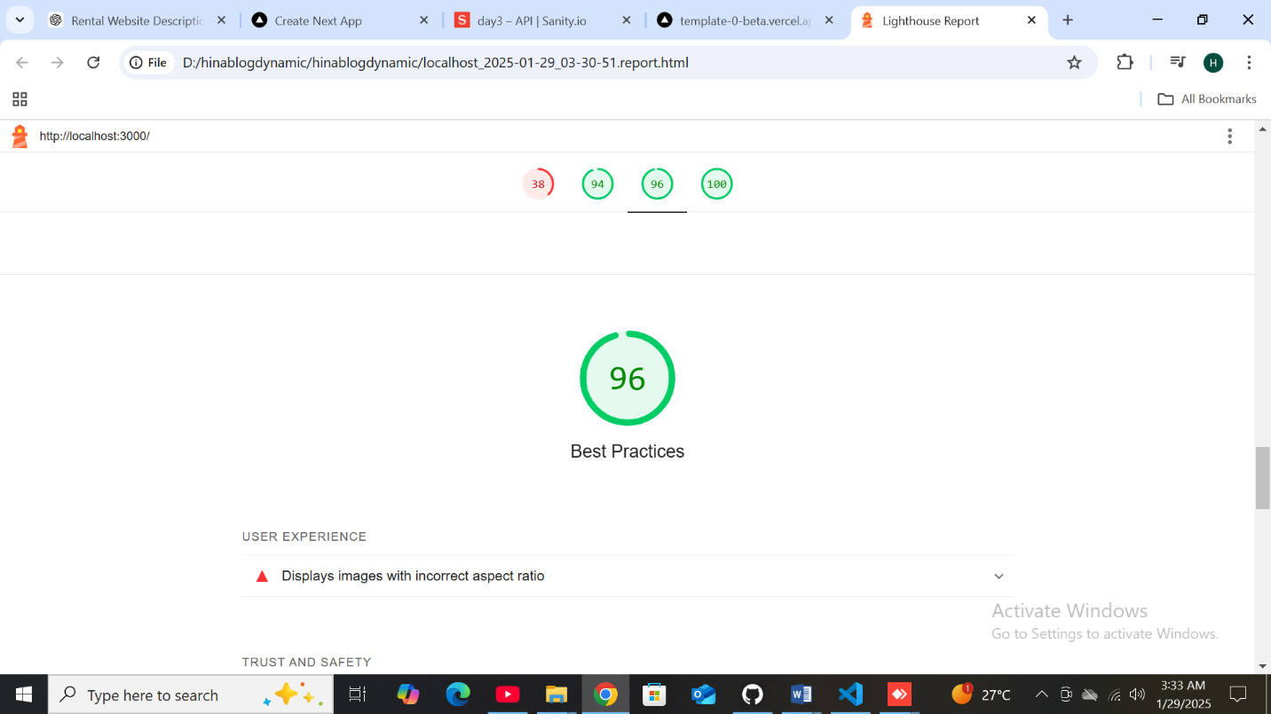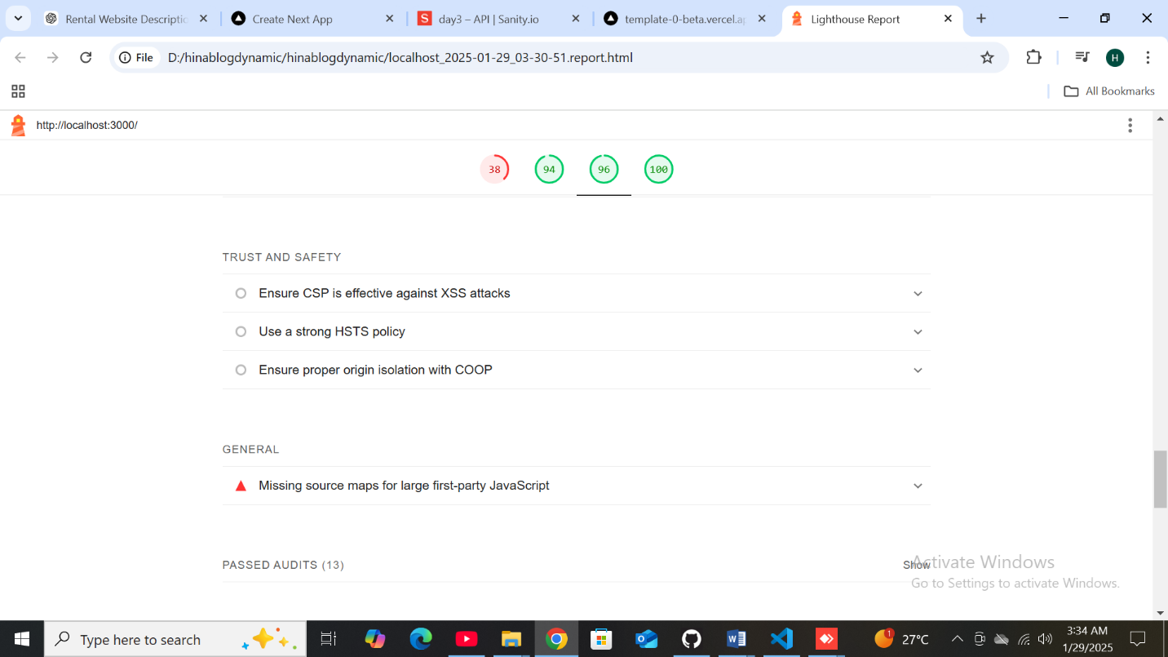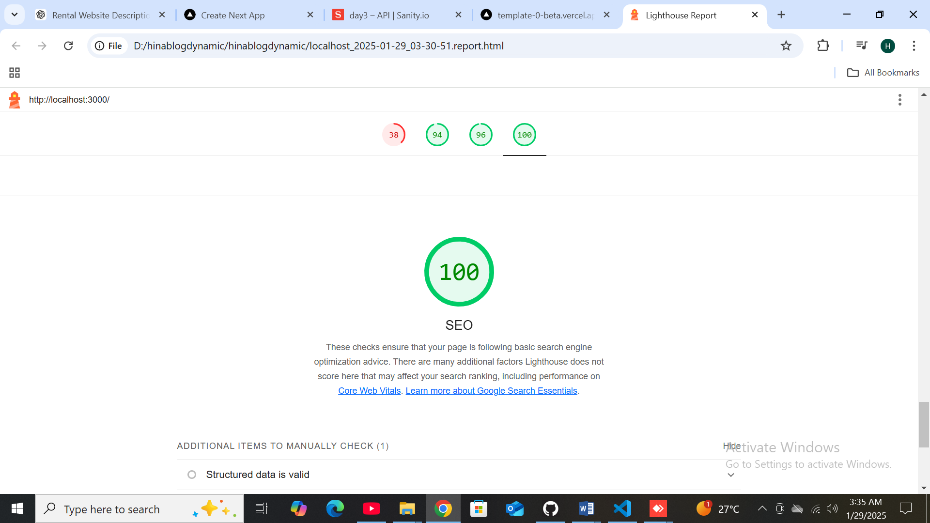

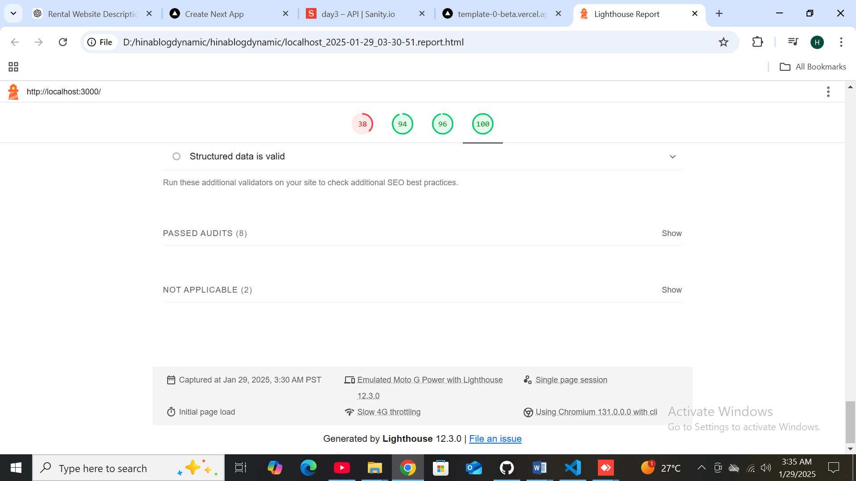

**DEveloper Resourse,**

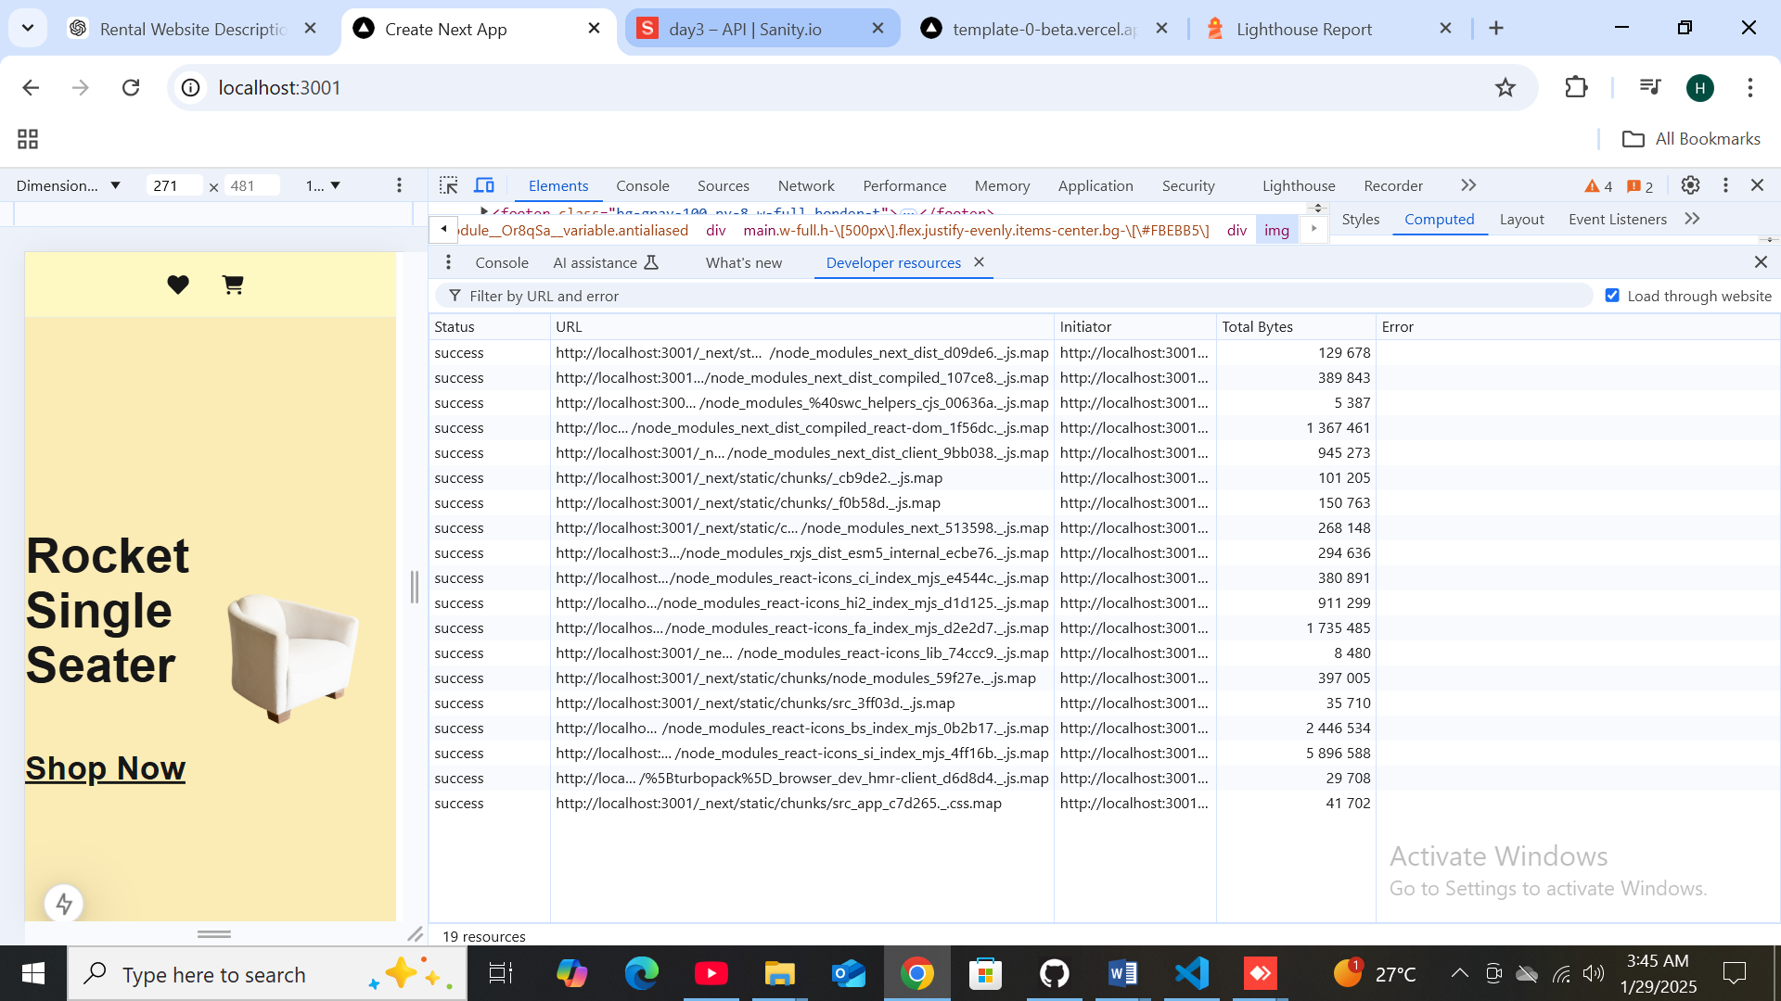

**Perfomance monitor:**

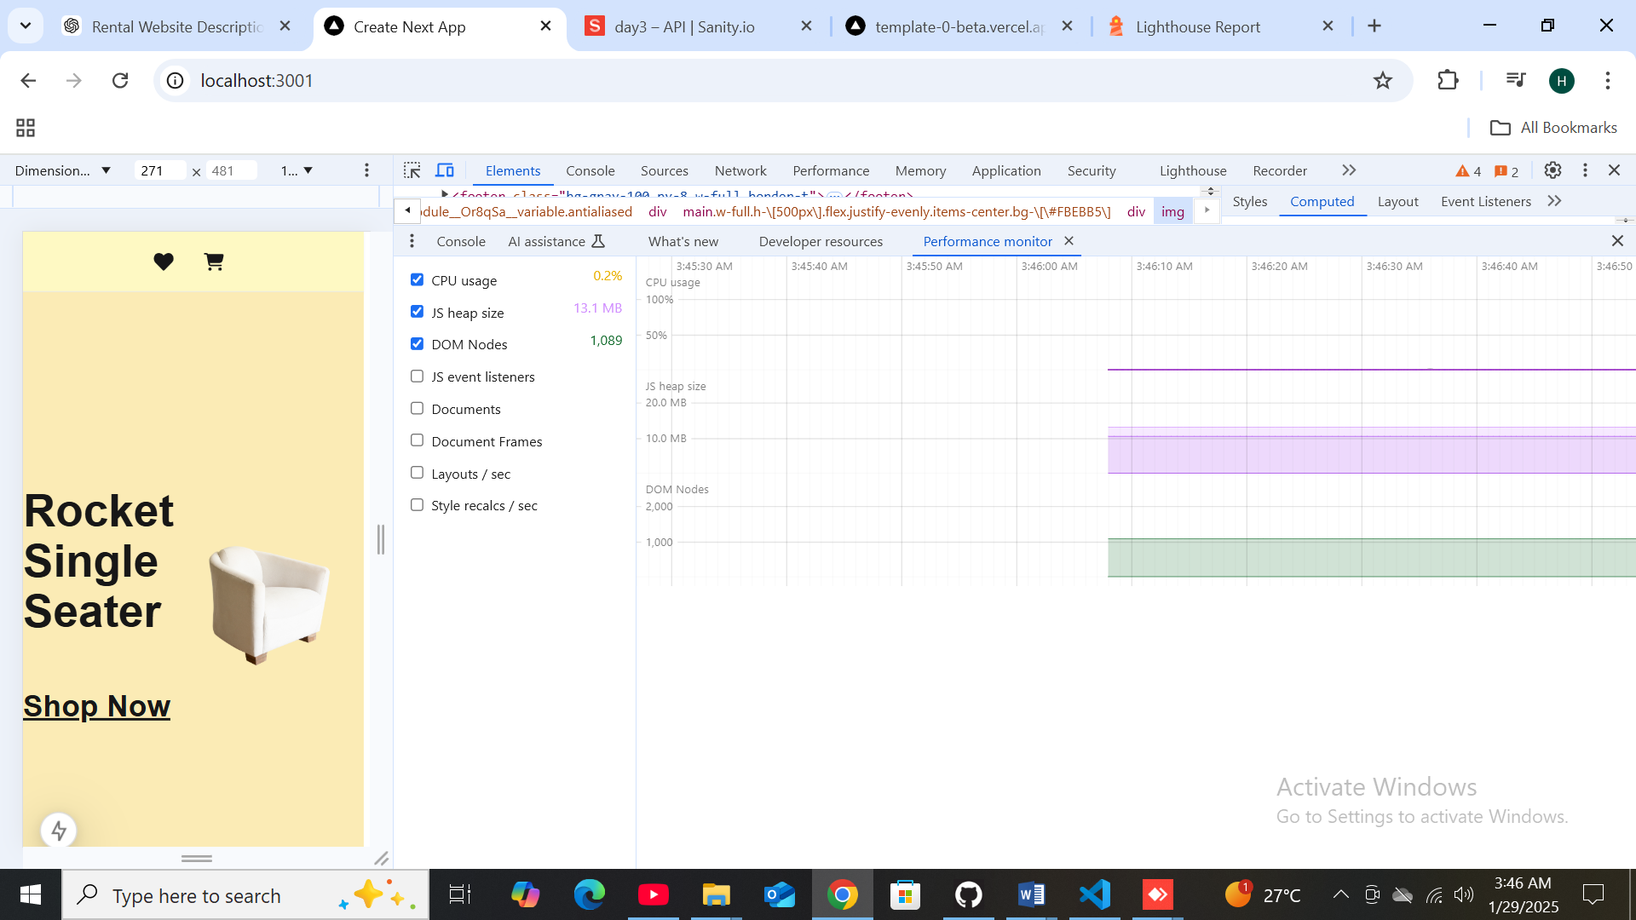

**“Issues that i found & Security”**

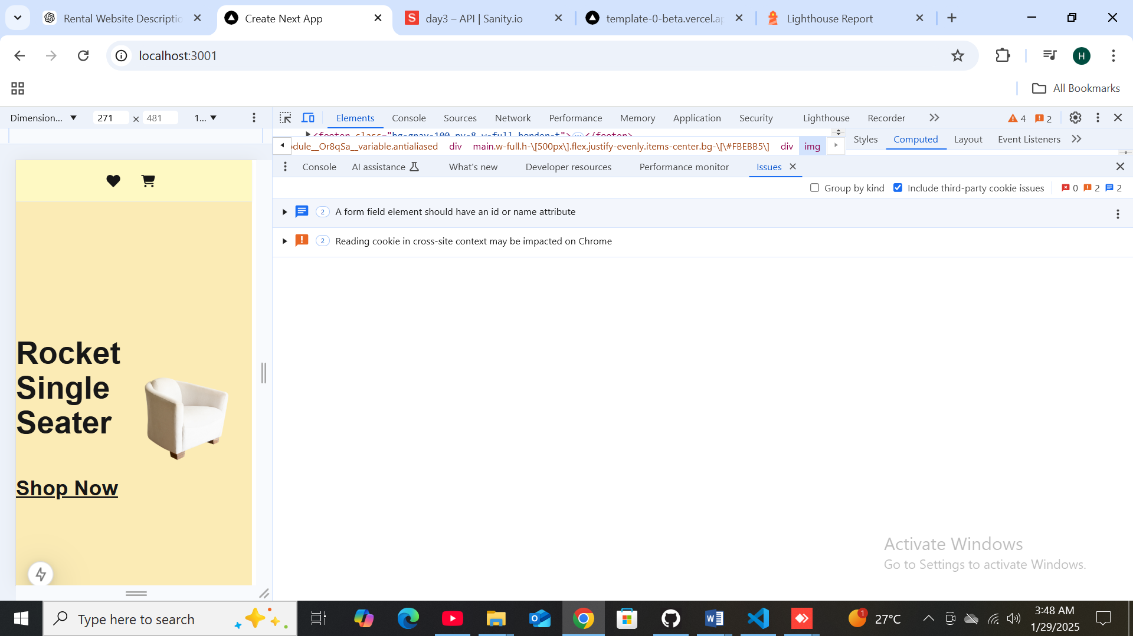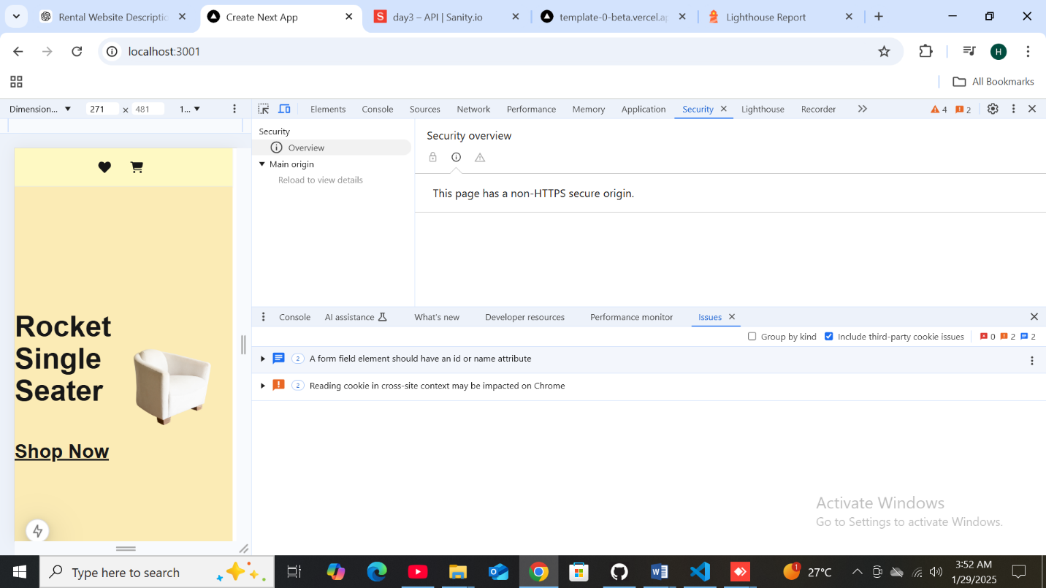

Trust and Safety

Ensure CSP is effective against XSS attacks

|  |  |  |
| --- | --- | --- |
|  |  |  |

Use a strong HSTS policy

|  |  |  |
| --- | --- | --- |
|  |  |  |

Ensure proper origin isolation with COOP

|  |  |  |
| --- | --- | --- |
|  |  |  |

General

|  |  |  |  |  |  |  |  |  |  |
| --- | --- | --- | --- | --- | --- | --- | --- | --- | --- |
|  | Passed audits (13)  Show   |  |  |  |  | | --- | --- | --- | --- | |  |  |  |  |   Not applicable (2)  Show  100  SEO  These checks ensure that your page is following basic search engine optimization advice. There are many additional factors Lighthouse does not score here that may affect your search ranking, including performance on [Core Web Vitals](https://web.dev/explore/vitals?utm_source=lighthouse&utm_medium=cli). [Learn more about Google Search Essentials](https://support.google.com/webmasters/answer/35769).  Additional items to manually check (1)  Hide  Structured data is valid  Run these additional validators on your site to check additional SEO best practices.  Passed audits (8)  Show  Not applicable (2)  Show   * Captured at Jan 29, 2025, 3:30 AM PST * Emulated Moto G Power with Lighthouse 12.3.0 * Single page session * Initial page load * Slow 4G throttling * Using Chromium 131.0.0.0 with cli.   THE END |
|  |  |
|  |  |
|  |  |
|  |  |
|  |  |
|  |  |
|  |  |
|  |  |
|  |  |
|  |  |
|  |  |
|  |  |
|  |  |
|  |  |
|  |  |
|  |  |
|  |  |
|  |  |
|  |  |
|  |  |
|  |  |
|  |  |
|  |  |
|  |  |
|  |  |
|  |  |
|  |  |
|  |  |
|  |  |
|  |  |
|  |  |
|  |  |
|  |  |
|  |  |
|  |  |
|  |  |
|  |  |
|  |  |
|  |  |
|  |  |
|  |  |
|  |  |
|  |  |
|  |  |
|  |  |
|  |  |
|  |  |
|  |  |
|  |  |
|  |  |
|  |  |
|  |  |
|  |  |
|  |  |
|  |  |
|  |  |
|  |  |
|  |  |
|  |  |
|  |  |
|  |  |
|  |  |
|  |  |
|  |  |
|  |  |
|  |  |
|  |  |
|  |  |
|  |  |
|  |  |
|  |  |
|  |  |
|  |  |
|  |  |
|  |  |
|  |  |
|  |  |
|  |  |
|  |  |
|  |  |
|  |  |
|  |  |
|  |  |

**Developer Resourses.**

